Work Breakdown Structure (WBS).
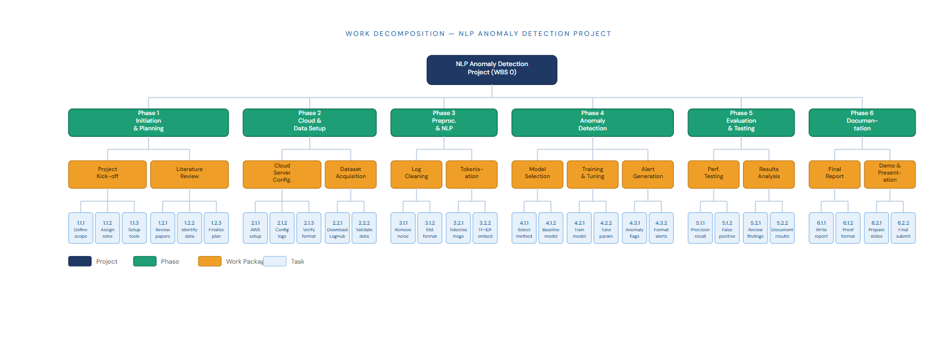

Delivery Roadmap

CHART
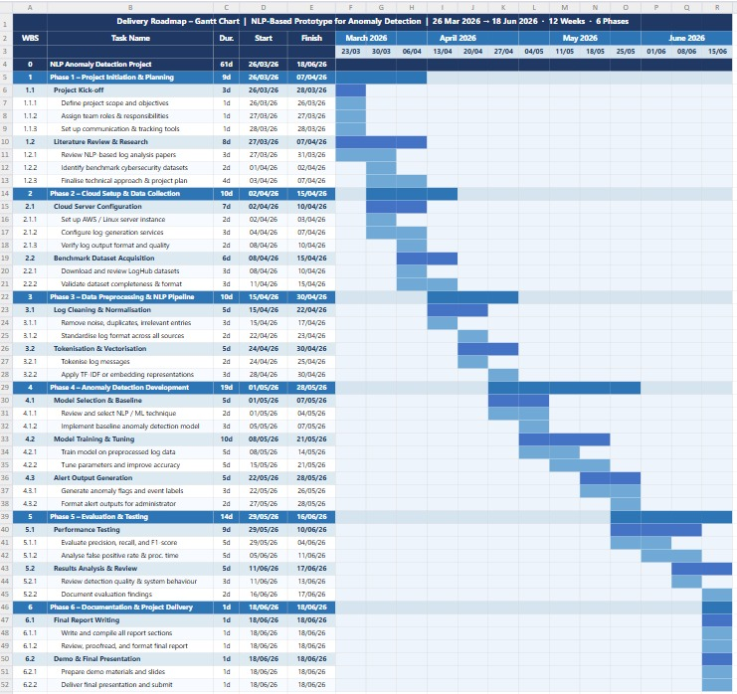

References
Project Management Institute. (2021). A guide to the project management body of knowledge (PMBOK® Guide) (7th ed.). PMI.
Kerzner, H. (2022). Project management: A systems approach to planning, scheduling, and controlling (13th ed.). John Wiley & Sons.
Wilson, J. M. (2003). Gantt charts: A centenary appreciation. European Journal of Operational Research, 149(2), 430–437. https://doi.org/10.1016/S0377-2217(02)00769-5
Rad, P. F., & Levin, G. (2006). Metrics for project management: Formalized approaches. Management Concepts.
Haugan, G. T. (2002). Effective work breakdown structures. Management Concepts.
Globerson, S. (1994). Impact of various work-breakdown structures on project conceptualisation. International Journal of Project Management, 12(3), 165–171. https://doi.org/10.1016/0263-7863(94)90007-8
Radujković, M., & Sjekavica, M. (2017). Project management success factors. Procedia Engineering, 196, 607–615. https://doi.org/10.1016/j.proeng.2017.08.048
Larson, E. W., & Gray, C. F. (2021). Project management: The managerial process (8th ed.). McGraw-Hill Education.
Maylor, H. (2010). Project management (4th ed.). Pearson Education.
Kelley, J. E., & Walker, M. R. (1959). Critical-path planning and scheduling. Proceedings of the Eastern Joint Computer Conference, 160–173.

Appendix

Appendix A: Work Breakdown Structure (WBS).

The resulting Work Breakdown Structure (WBS) of the project is a hierarchical breakdown of all the activities that were necessary to complete the project, i.e. the completion of the NLP-based anomaly detector system successfully. It breaks down the project into key stages, such as project initiation and planning, setup of cloud infrastructure, data collection, data preprocessing, development of the model, evaluation of the model and documentation. The different stages are also subdivided into smaller work packages so that the tasks are well defined, manageable as well as measurable. This systematic division assists in the making sure that every part of the project scope is discussed in an organized manner and the chance of missing out on vital points is minimal. The WBS is also useful in effective assignment of responsibilities and in increasing monitoring and control during the project lifecycle.

Appendix B: Gantt Chart (Project Schedule).

The Gantt chart gives a visual presentation of the project schedule that identifies the schedule of each of the tasks, their start dates, duration, and due dates. It also shows the flow of action clearly with some tasks needing to be done before others can commence like cloud setup before data preprocessing and model development. Besides, the chart shows the places where work can be performed simultaneously so that the resources and time were effectively utilized. The Gantt chart allows tracking the progress, revealing the delays, and coordinate the various stages of the project in a better way by displaying the project schedule in a systematic manner.

Appendix C: Tools and Software used.

The Work Breakdown Structure, as well as the Gantt chart, had to be prepared with the help of different tools and software to be clear and accurate in terms of planning. The WBS and schedule were designed and structured using common productivity tools, e.g. Microsoft Word, Excel, or project. Moreover, the visualization tools have possibly been applied to augment the chart and diagram representations. Such tools helped to systematize the project activities and communicate them clearly.

Appendix D: Assumptions and Constraints.

This project was planned with a number of assumptions in order to achieve its successful implementation. It is projected that the data required will be received within the desired period and that the members of the team will have the technical know-how to accomplish their designated duties. It is also presumed that the cloud infrastructure would be stable and accessible during the project period. Nonetheless, there are some constraints associated with the project such as time constraints, resource availability, and task dependencies. As an illustration, some steps like preprocessing data should be accomplished before training the model can take place which can affect the timeline infrastructure in case of delays.

